Hadoop Word Count Using MapReduce

1. Objective
To create a text file, store it in HDFS, execute the Word Count MapReduce program using Hadoop, and view the word frequency results.

2. Procedure

Step 1: Create a New Text File
touch prac.txt
Data Science is the process of collecting, analyzing, and interpreting data to discover useful insights and support decision-making. It combines statistics, programming, machine learning, and domain knowledge to solve real-world problems. Data Science is widely used in industries such as healthcare, finance, marketing, and technology to improve efficiency and predict future trends.

Step 2: Verify the File Contents
cat prac.txt

Step 3: Upload the File to HDFS
hdfs dfs -put prac.txt /demo

Step 4: Execute the Word Count Program
hadoop jar $HADOOP_HOME/share/hadoop/mapreduce/hadoop-mapreduce-examples-*.jar wordcount /demo /output

Step 5: Check the Output Directory
hdfs dfs -ls /output

Step 6: View the Word Count Results
hdfs dfs -cat /output/part-r-00000
3. Source Code

Input File (prac.txt)
Data Science is the process of collecting, analyzing, and interpreting data to discover useful insights and support decision-making. It combines statistics, programming, machine learning, and domain knowledge to solve real-world problems. Data Science is widely used in industries such as healthcare, finance, marketing, and technology to improve efficiency and predict future trends.

Commands Used
touch prac.txt
Data Science is the process of collecting, analyzing, and interpreting data to discover useful insights and support decision-making. It combines statistics, programming, machine learning, and domain knowledge to solve real-world problems. Data Science is widely used in industries such as healthcare, finance, marketing, and technology to improve efficiency and predict future trends.

touch prac.txt
hdfs dfs -put prac.txt /demo
hadoop jar $HADOOP_HOME/share/hadoop/mapreduce/hadoop-mapreduce-examples-*.jar wordcount /demo /output
hdfs dfs -ls /output
hdfs dfs -cat /output/part-r-00000

4. Screenshots

Creating the Input File

Verifying the File

Running Word Count
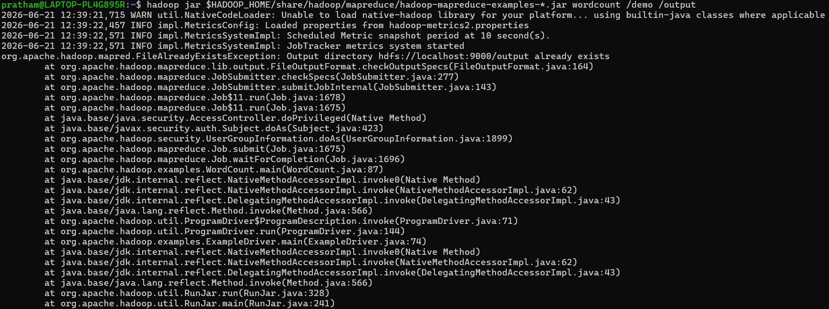

Screenshot 5: Checking Output Directory

Screenshot 6: Viewing Word Count Results

5. Conclusion
The Hadoop MapReduce Word Count application was successfully executed. The input text file was uploaded to HDFS, processed using the built-in Hadoop Word Count program, and the output containing the frequency of each word was generated and stored in the HDFS output directory. This experiment demonstrates the basic working of Hadoop MapReduce for distributed data processing.

